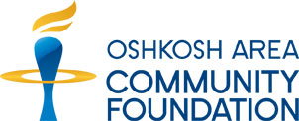
Education Grant Project Evaluation
(Due 30 days after ending grant period)

Name of School:
Name of Grant Awarded:
Amount of Grant Awarded: Date of Grant:
Person Completing Report:
Phone: Email:

Please answer the following questions on a separate sheet of paper. Attach supporting information if needed.
- Please describe the number of students who benefited from this project and how the educational classroom grant enhanced the student experience and learning skills.
- Do you feel this project was worthwhile? Did it meet your expectations, and why?
- Will this project/program likely become a regular part of your classroom programming?
- Describe the difference this project/program has made with one or more success stories.

Return the completed Education Grant Project Evaluation to:
Cheryl Fowler, Education Coordinator
Oshkosh Area Community Foundation
Cheryl@oshkoshareacf.org

230 Ohio Street Suite 100
Oshkosh, WI 54902
920-426-3993

