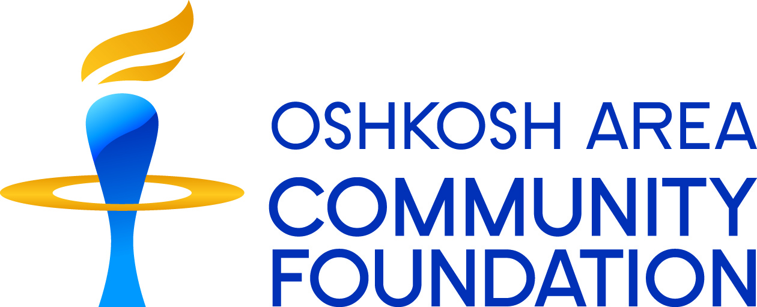

# FINAL REPORT

# Grants for less than $10,000

|  |  |
| --- | --- |
| **GRANTEE:** organization | **DATE:** select date |
| **PROJECT:** project | |
| **GRANT AMOUNT:** $ grant amount | **GRANT #:** 201##### |
|  | |
| **Final report completed by:** | |
| **name:** name | **title:** job title |
| **phone:** phone | **email address:** email address |

Final reports to the Community Foundation help us understand how grants benefit our community. The insights you provide by answering the questions below help to substantiate our past grantmaking and inform our future grantmaking. We encourage you to go beyond simply documenting your activities and costs. We want to hear about your outcomes and successes, but also your challenges, difficulties, and even failures related to this grant and what you have learned that will make your organization more effective.

**Please ANSWER ALL QUESTIONS BELOW.**

**be as candid, reflective, and concise as possible.**

**1. Demonstrate impact and accountability**

* How has the work supported by this grant benefited our community and furthered the mission of your organization? If your grant agreement included specific outcomes in clause #7, please share progress towards those outcomes.
* Describe how the Community Foundation’s grant was spent.
* Was there any unspent grant money? If so, please return unspent dollars.

Click here to enter text.

**2. Reflect on what you learned during the grant period**

* Describe any unforeseen circumstances, challenges or successes during the grant period. How did they cause you to adjust what you were doing?

Click here to enter text.

**3. Share your success**

* Provide at least one example, story or quote that illustrates how a specific group or individual was affected by the work supported by this grant.
* Do you have photos or a short video clip illustrating the impact of your program that the Community Foundation could share publicly so others may learn from your work? If so, please send along with your report.

Click here to enter text.

**4. Help us improve**

* How can the Community Foundation improve its competitive grant processes?

Click here to enter text.